SOP Deploying shared printers

Traditionally, you used scripting to deploy printers. With this method, you create a logon or startup script and deploy this logon script via Group Policies. When machines start up or   
users log on, the logon script automatically sets up printers.

Once you have set up a shared printer, such as the shared Sales Group color printer, as   
shown in this chapter, you can deploy it. There are several ways to automate local client   
printer deployment, including using PowerShell, WMI, the Printui.dll utility, and the   
Wscript.Network COM object. All of these methods have been in use for a long time and

are quite efficient, although PowerShell is the preferred way, naturally.

Getting ready

To deploy a printer to a client, you first need a client computer system. Our demo lab   
includes a Windows 10 Enterprise client (SG-CL1), which we use in this recipe. To test this recipe, you need the client computer, the print server (PSVR), and the domain controller (DC1).

Once you create the client, you can run the following commands to add it to the domain in the Sales OU (created separately):

$Cred = Get-Credential 'Reskit\administrator'   
 # you enter the password

$OUPath = 'OU=Sales, DC=Reskit,DC=Org'   
 Add-Computer -DomainName 'Reskit' `   
 -DomainCredential $cred

Next, you need a Group Policy object that deploys the logon script. The easiest way to   
create this Group Policy Object (GPO) is to use the GUI-there are no PowerShell cmdlets   
(or WMI/.NET objects) that can help.

To create the GPO, you use the Group Policy Management Console (GPMC) tool. This tool is part of the management tools for Active Directory, and is also part of the Remote Server Admin Tools (RSAT) that you can download for client systems. Once you install the   
GPMC, you can run it and expand the domain to make our Sales OU visible:

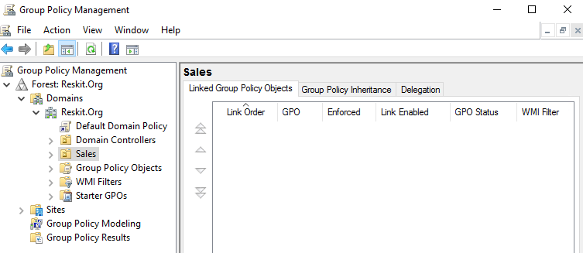

Next, you right-click the Sales OU, specify the Group Policy Name, and click OK:

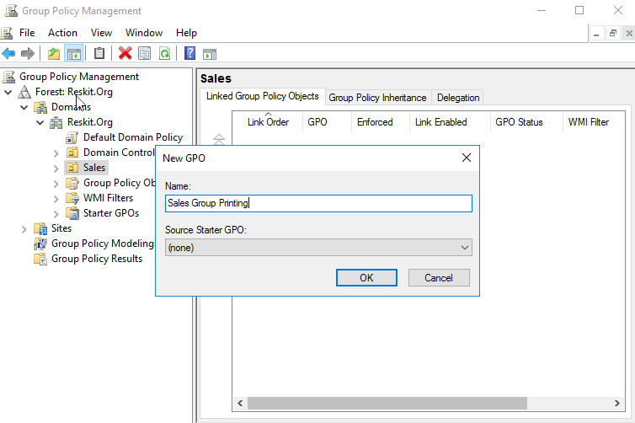

With the GPO created, right-click the GPO and select Edit:

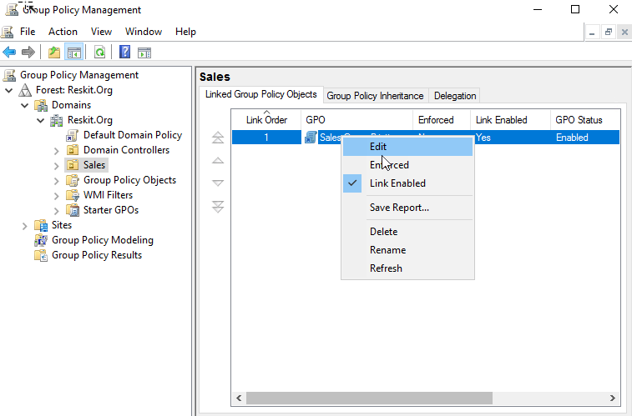

This brings up the Group Policy Management Editor. Select the User Configuration | Windows Settings | Scripts (Logon/Logoff):

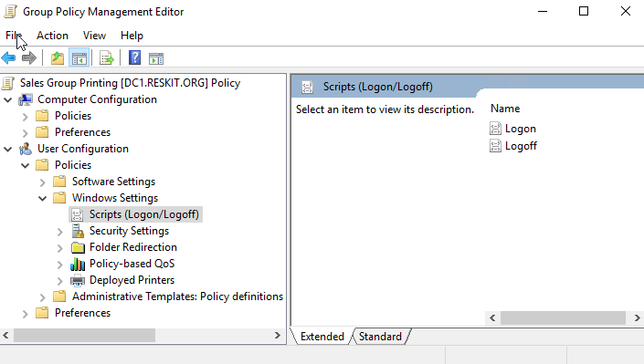

Then double-click Logon to bring up the Logon Properties dialog, and then click on the PowerShell Scripts tab:

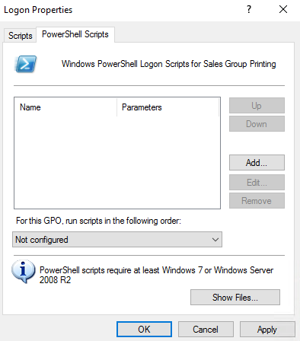

From this dialog, click on Add to bring up the Add a Script dialog:

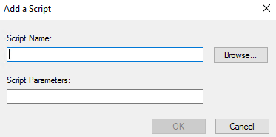

From this dialog, enter the Script Name Sales Group Logon Script.ps1, then click on OK, which brings up the Logon Properties box with the script shown here:

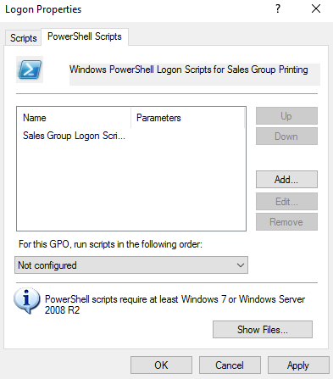

Note the file name in this dialog box. This file (Sales Group Logon Script.ps1) is a file within the Logon Script folder inside the GPO object in your SYSVOL folder on your   
domain controller. The path for the Logon Script folder was   
Reskit.Org\SysVol\Reskit.Org\Policies\{CF4F8264-0FD7-4D21-8267-8F36D7CE 3DCF}\UserScripts\Logon. If you are testing this, you should see a different GUID in   
this path.

From the Logon Properties dialog, click OK to close the dialog, then close the GPMC editor. These steps have created an empty logon script. You can add the content for this logon   
script by going through the following recipe.

How to do it:

Once you have created the logon script GPO, as shown previously, it's time to create the script:

1.Using the ISE, open the script file you created in the introduction to this SOP   
and enter the logon script:

# Sales Group Logon Script.ps1

# Logon Script for Sales Group to add printer

# 1. Start transcript

Start-Transcript -Path C:\transcript\transcript.txt   
 -Append

# 2. Log information to the transcript

'*** Logon script - Sales GVroup Logon Script.ps1'   
 '*** Date/time: [{0}]' -f (Get-Date)

# 3. Setup up printer connection then try to connect   
 $Connection = 'PSRV\SGCP1'

Try {

$Printer = Get-Printer -Name $Connection   
 If ($Printer)

{

'*** Sales group printer found'   
 $Printer

}

Else

{Throw "Printer not found"}

}

Catch {

'*** SG Printer does not exist'

'*** Date/time: [{0}]' -f (Get-Date)   
 '*** Adding SG Printer '

Add-Printer -ConnectionName $connection -Verbose   
 Get-Printer -Name $Connection   
 '******';''

}

# 5. And stop the transcript

Stop-Transcript

2.Once you create and save the script, you can test it by logging onto the SG-CL1   
computer and displaying the file C:\Transcript\Transcript.txt, which on

the first logon looks like this:

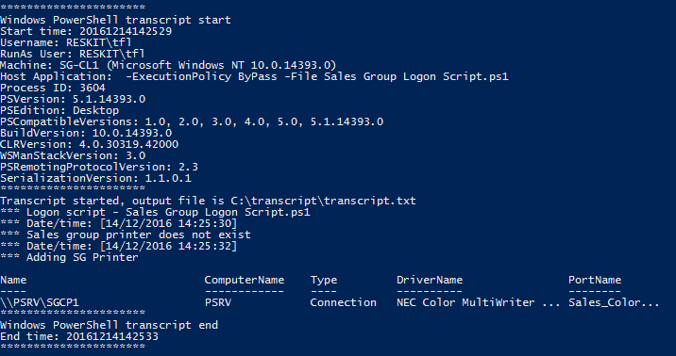

3.Once the logon script has installed the printer, subsequent logon scripts create a   
transcript entry that looks like this:

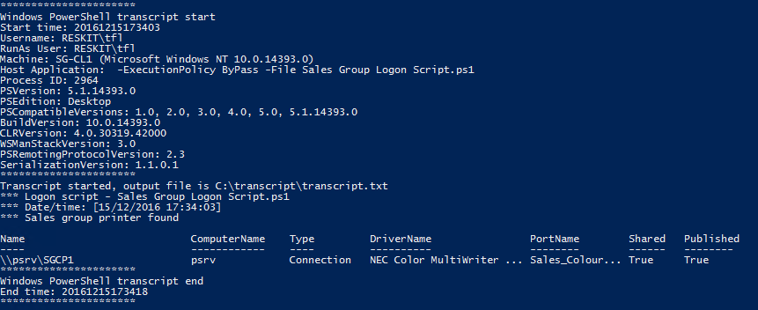

How it works:

The recipe creates a GPO to distribute a logon script to users whose user accounts are in the Sales OU. You set up the logon script by following the steps in the introduction to this   
recipe. Then, you create and save the actual logon script. Finally, you edit the empty script   
file to add the logon script details.

Once you have this logon script created, the printer is automatically added to the Sales   
Group users' systems. New users in the Sales Group just need to log off and log on again to get the printer setup.

There's more:

This recipe showed you one way to deploy a printer through the use of a logon script. This method is one that has been used by IT professionals for decades. It is also a very flexible   
approach for many organizations-you can do quite a lot with the logon script.

Another way to deploy printers to client systems would be to use Group Policy preferences (GPP). The use of GPP adds flexibility to the process, but it is essentially an all-GUI   
administration experience. Windows Server 2016 does not provide cmdlets that would   
enable you to automate printer management fully via GPP or GPO.

See   
<https://technet.microsoft.com/en-us/library/cc754699(v=ws.11).aspx> for more details on how to deploy printers using Group Policies.